Nursing Kit
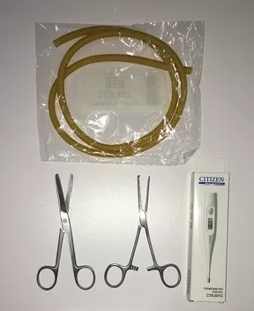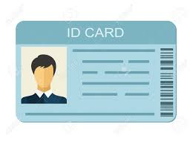
Strap for blood extraction
Straight Kocher Clamp
Straight Kocher Clamp
ID card
Straight Kocher Clamp
Digital Thermometer
Straight Kocher Clamp
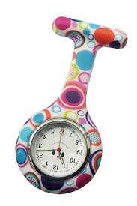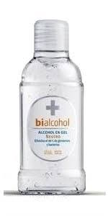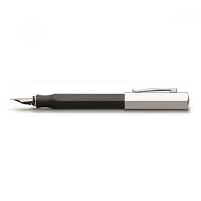
pen
Silicone fob watch
Alcohol-based hand gel

Sphygmomanometer or blood pressure meter
Stethoscope
Vademecum

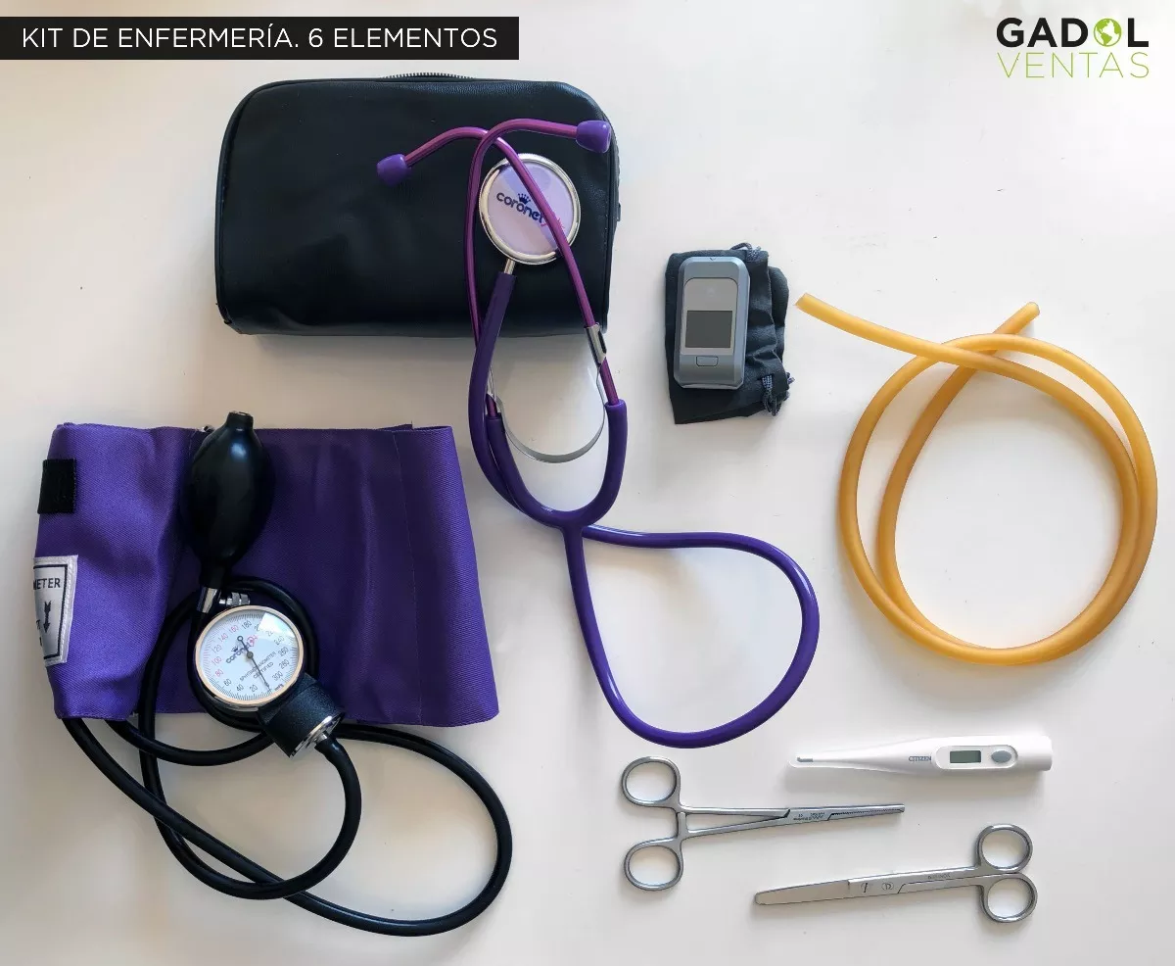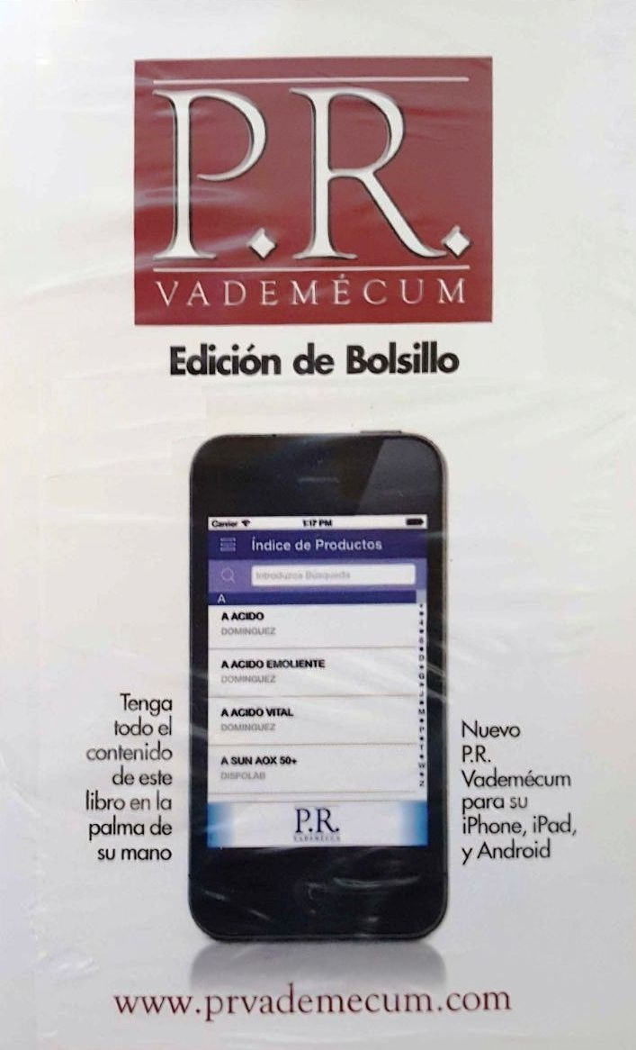
Oximeter
Pinza diserccion c/dientes

Nursing Elements
Español | Ingles | Español | Ingles
Camilla | Stretcher | Zalea | Disposable bed cover
Tensiómetro | Blood pressure meter  Sphygmomanometer | Gasas Estériles. | Disposable Gauze
Estetoscopio | Stethoscope | Caja Quirúrgica | Surgical suture case
Descargador de agujas | Syringe pump | Tijeras | Scissors
Caja de guantes descartables | Disposable gloves box | Termómetro | Thermometer
Baja lenguas | Tongue lowerer | Lazo | Strap (for blood extraction)
Linterna de bolsillo | Pocket torch | Camisolín | Hospital gown
Algodón | Cotton | Guía de suero | Support serum wheelset /  Docking serum support
Alcohol en gel | Alcohol-based hand gel | Caja de curaciones | Surgical case
Bolsa de residuos roja | Red trash bag | Set de emergencias | Emergency kit
Bolsa de residuos negra | Black trash bag | Manoplas | Mitts
Cuello ortopédico | Cervical collar | Máscara de oxígeno para niños / Adultos | Child oxygen mask  Adult oxygen mask
Hisopos | Cotton swabs | Riñonera | Nursing Kit
Agua oxigenada | Hydrogen peroxide | Carpeta de turnos | Appointment folder
Calendario de vacunación | Vaccination schedule | Vías / suero / goteo | Serum IV line / drip
Carpeta de laboratorio | Lab folder | Agujas / Jeringas | Needles / Syringes
Cintas reactivas | Test strips | Jarabe | Syrup
Balanza | Scales | Vendas | Bandages / Dressings
Carro de paro | Emergency trolley | Dispositivo de punción | Puncture device
Barbijo | Disposable surgical mask | Antiparras | Goggles
Aspirinas | Aspirins | Oxímetro | Oximeter
Desfibrilador | Defibrillator | RCP | CPR

